**Life Cycle Chart**

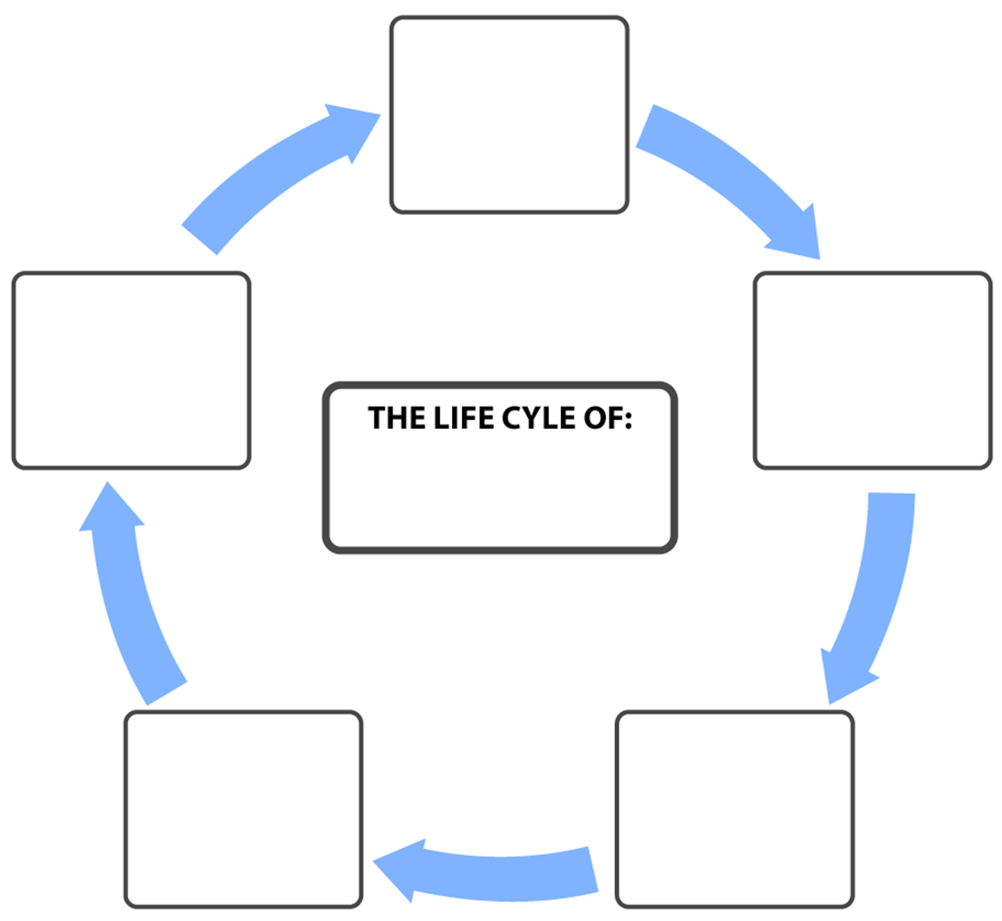

BSFX

Client enters credentials for FXCM LIVE or DEMO account.

When the Forex market closes, BSFX disconnects from FXCM and waits for the market to open, then re-connects.

Credentials are confirmed and data tables are put on listeners.

Listeners check for events triggered by ForexConnect API, and flow into the appropriate class within BSFX to be managed.

If Parameters are met, based on the data FXCM is providing, a buy/sell order is placed and managed.